**SQL Lesson 13: Inserting rows:**

1. 1. Add the studio's new production, Toy Story 4 to the list of movies (you can use any director)

2.Toy Story 4 has been released to critical acclaim! It had a rating of **8.7**, and made **340 million domestically** and **270 million internationally**. Add the record to the **BoxOffice** table.

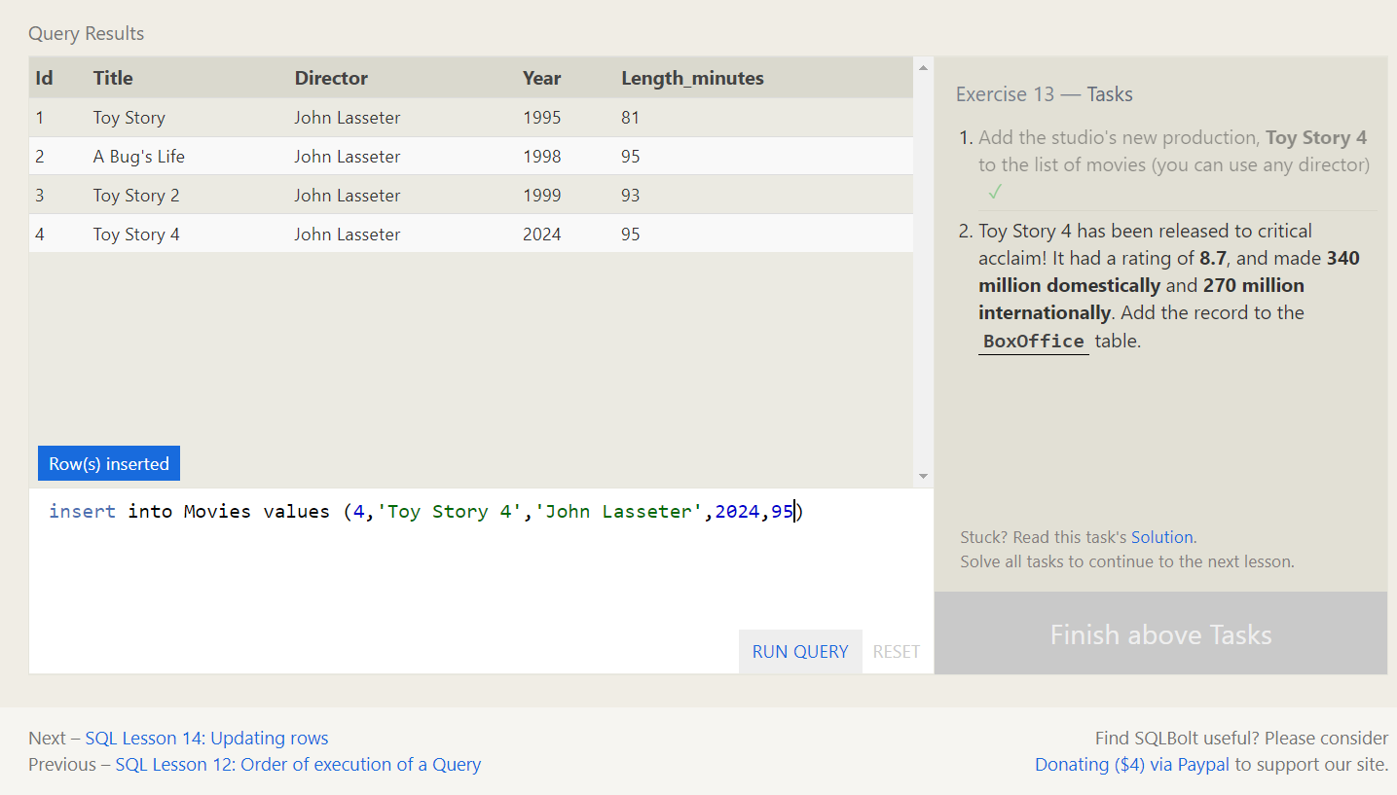

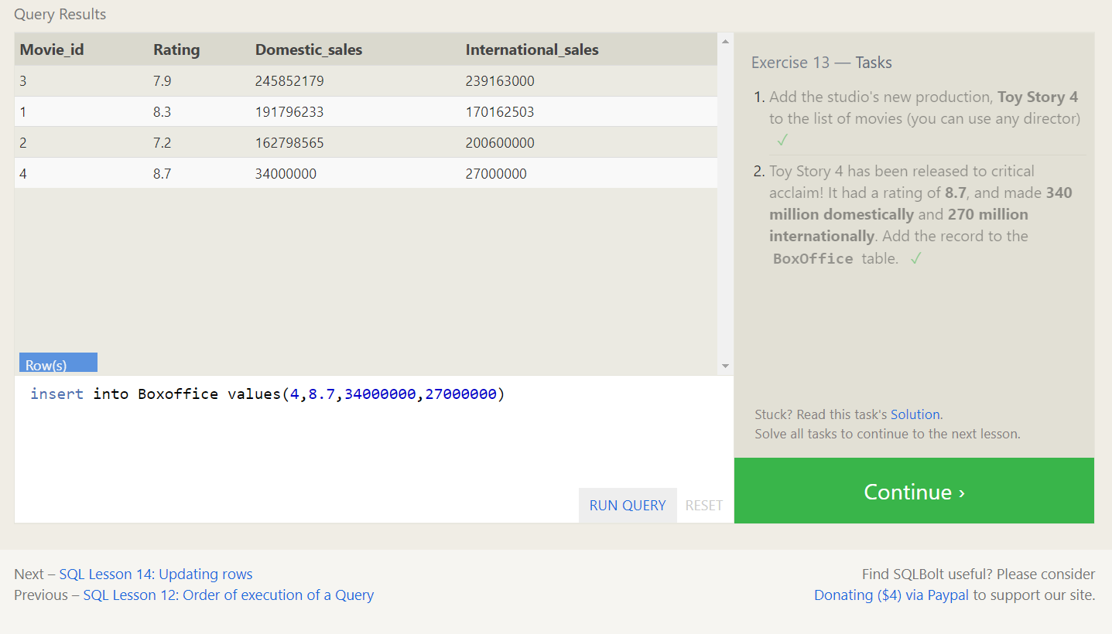

**SQL Lesson 14: Updating rows:**

1. The director for A Bug's Life is incorrect, it was actually directed by **John Lasseter**

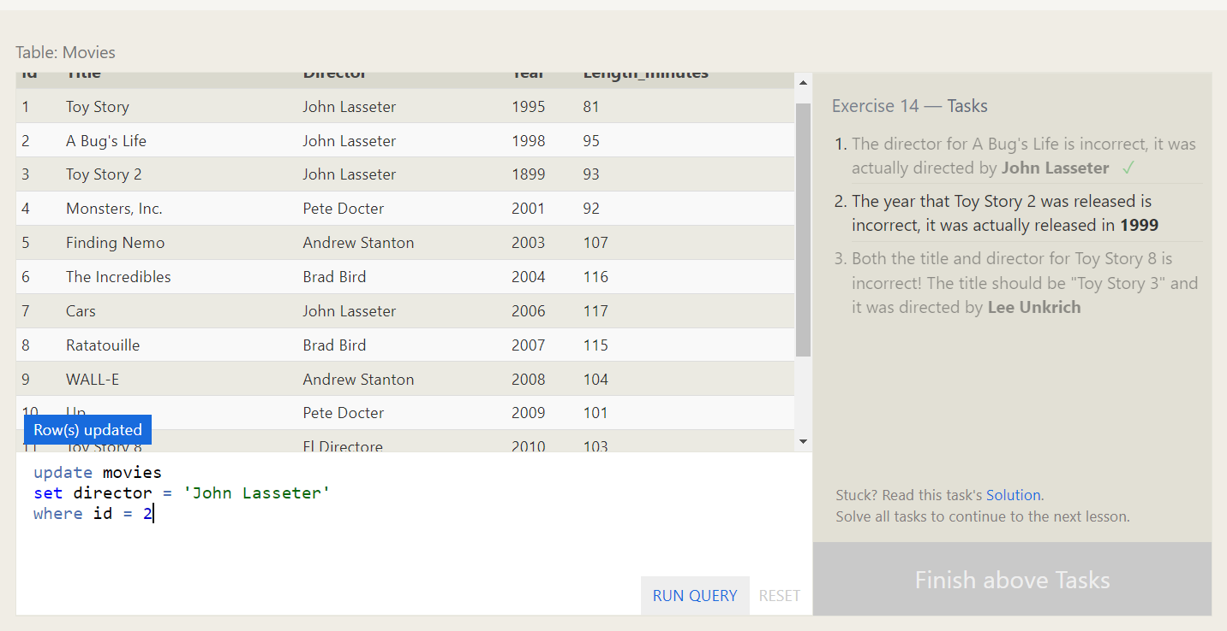

1. The year that Toy Story 2 was released is incorrect, it was actually released in **1999**

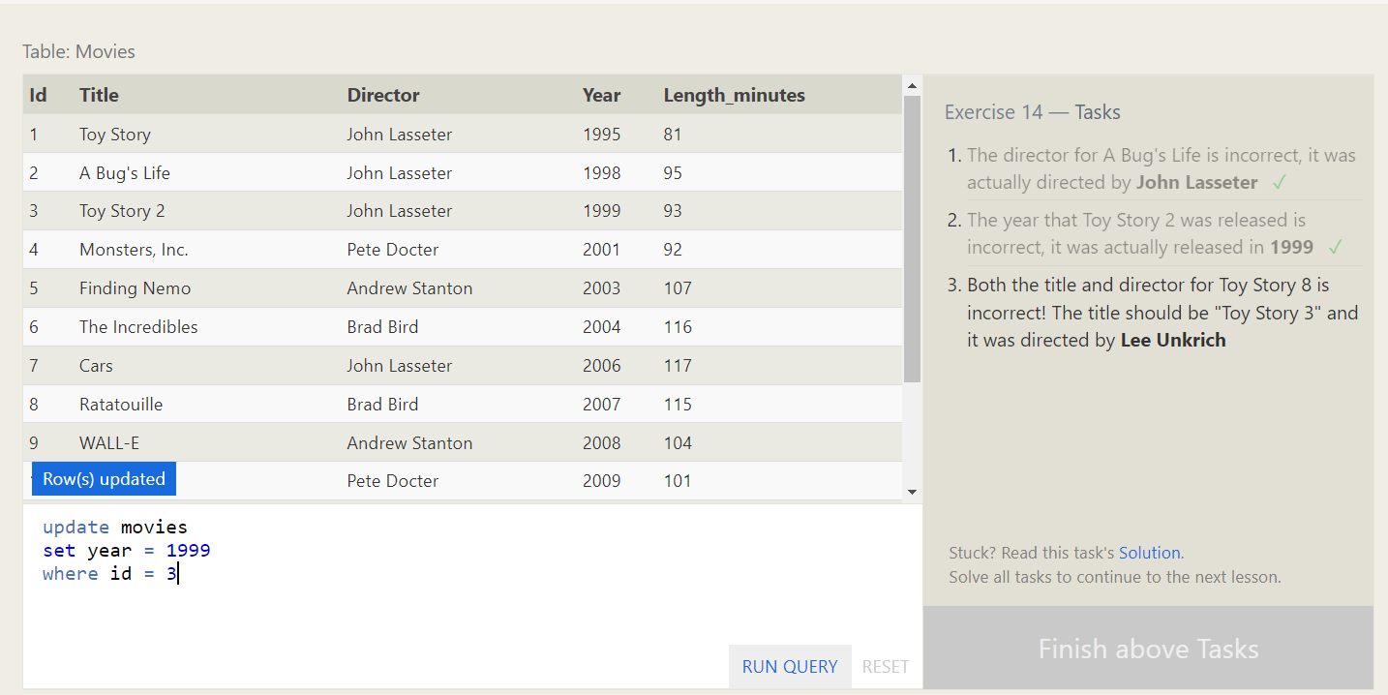

1. Both the title and director for Toy Story 8 is incorrect! The title should be "Toy Story 3" and it was directed by **Lee Unkrich**

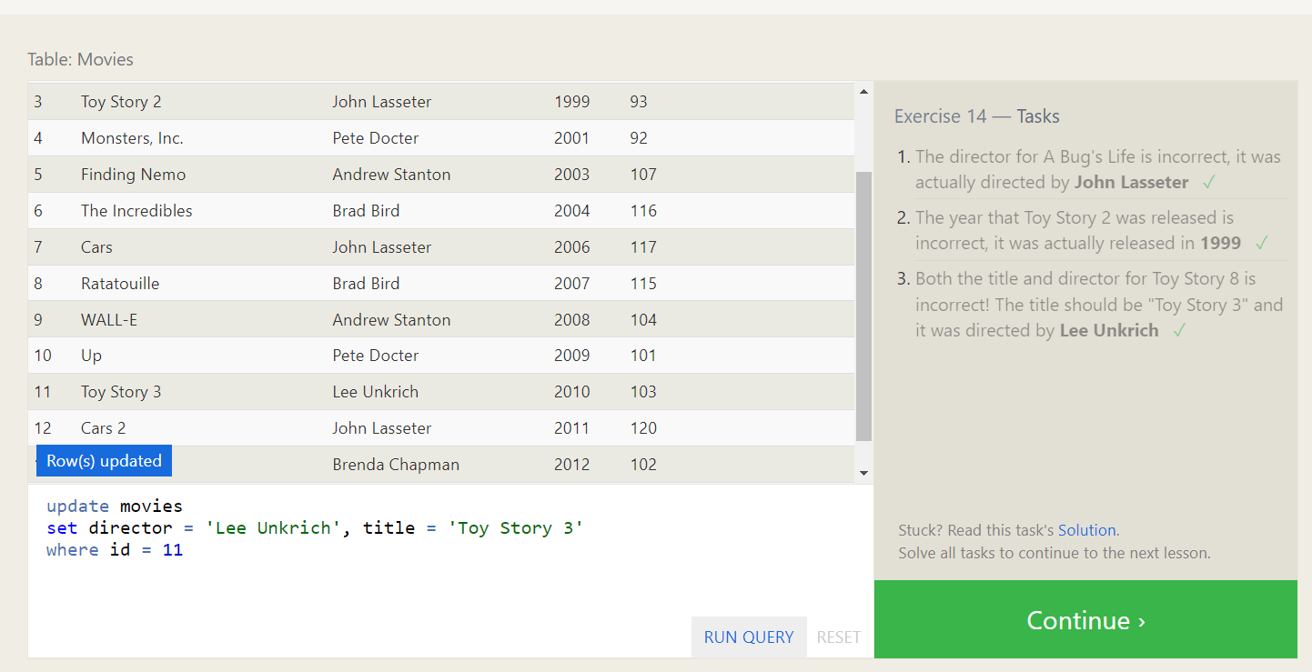

**SQL Lesson 15: Deleting rows:**

1. This database is getting too big, lets remove all movies that were released **before** 2005.

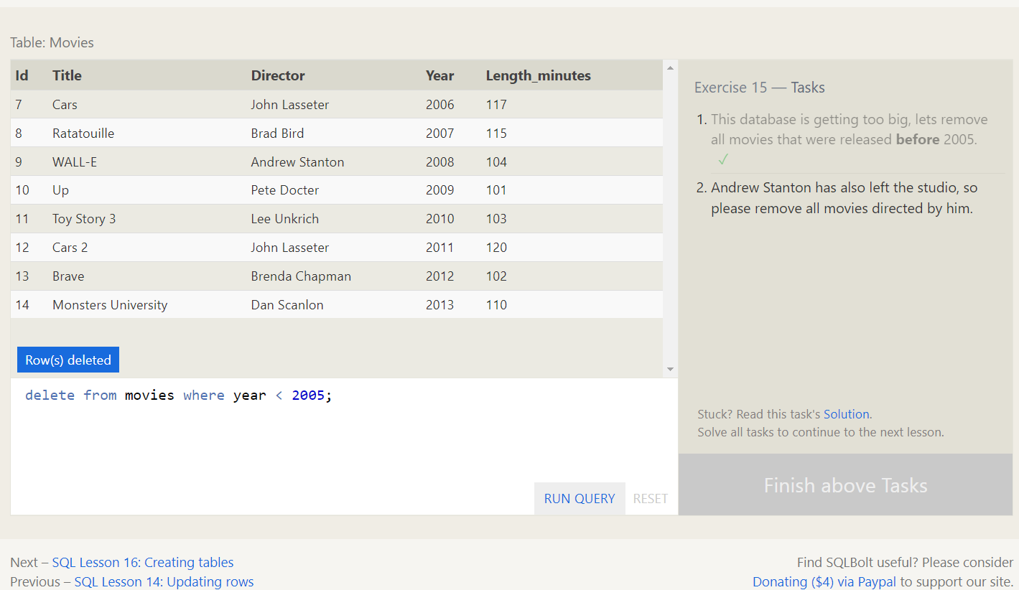

2.Andrew Stanton has also left the studio, so please remove all movies directed by him.

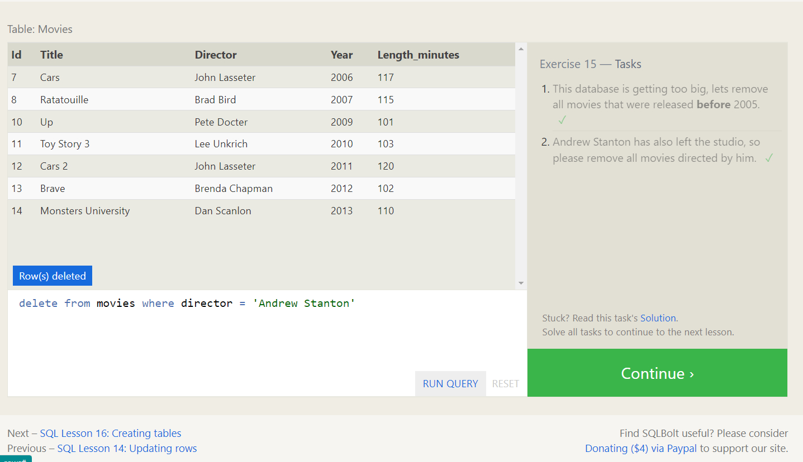

**SQL Lesson 16: Creating tables:**

Create a new table named **Database** with the following columns:

– **Name** A string (text) describing the name of the database  
– **Version** A number (floating point) of the latest version of this database  
– **Download_count** An integer count of the number of times this database was downloaded

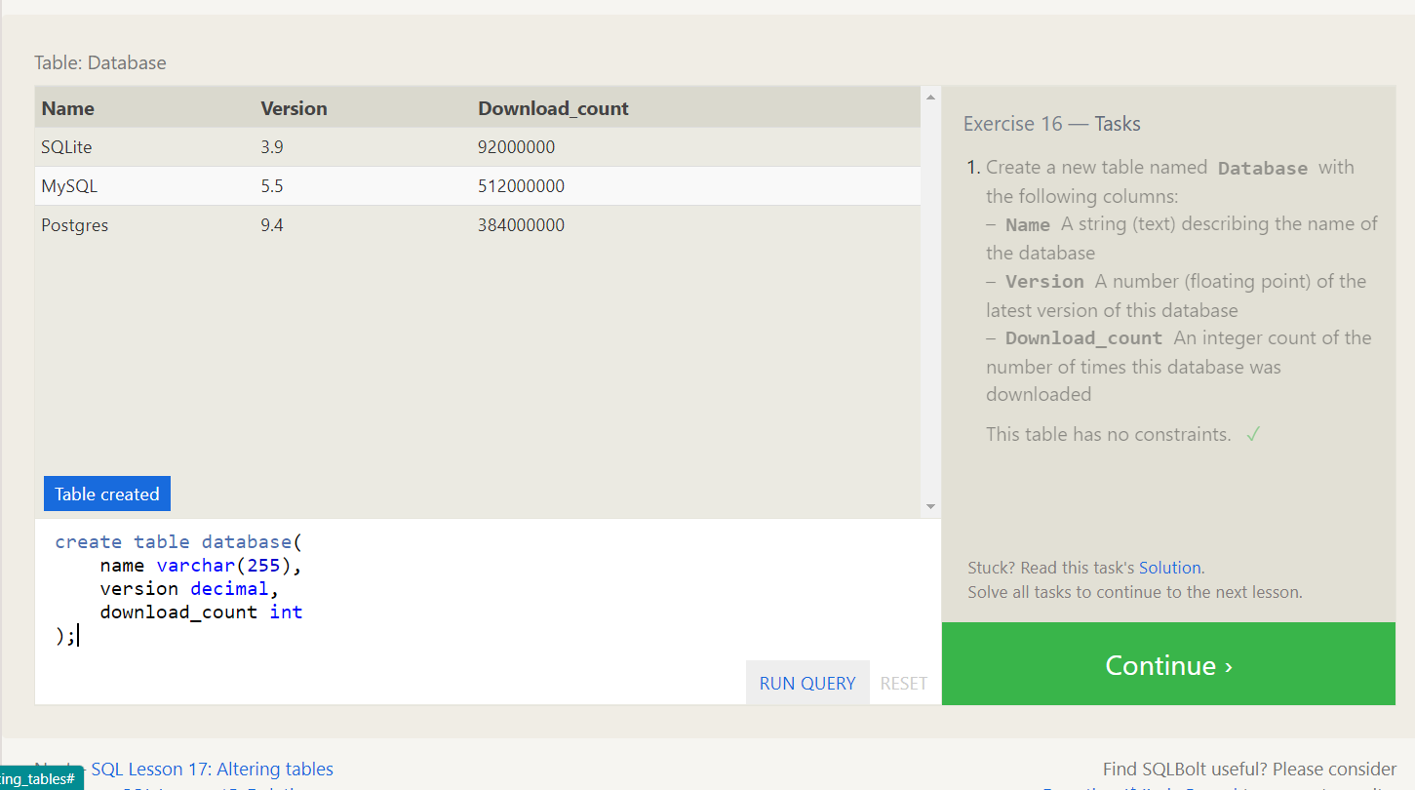

**SQL Lesson 17: Altering tables:**

1. Add a column named **Aspect_ratio** with a **FLOAT** data type to store the aspect-ratio each movie was released in.

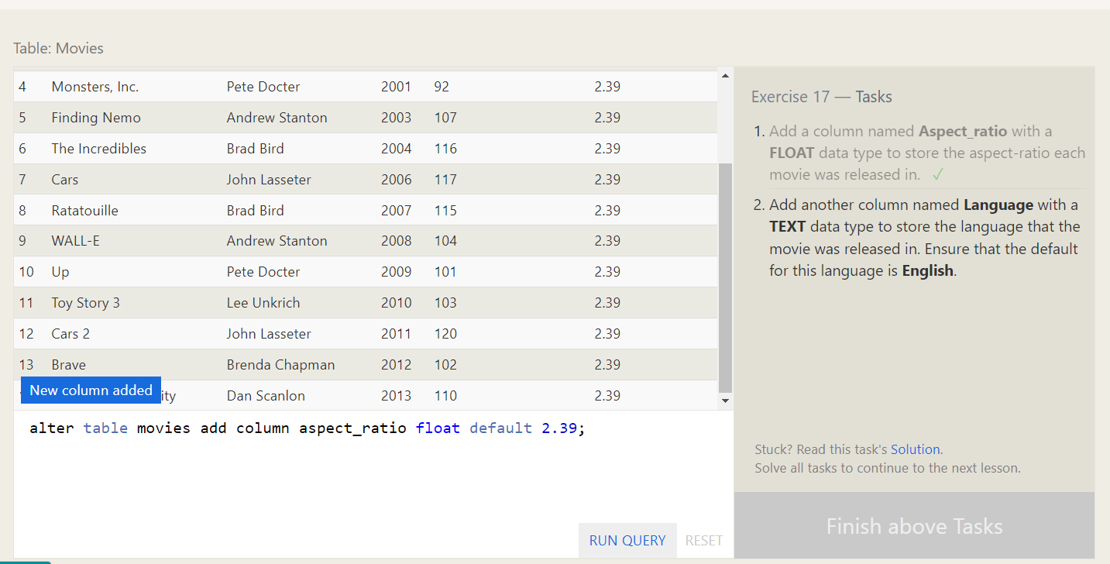

2. Add another column named **Language** with a **TEXT** data type to store the language that the movie was released in. Ensure that the default for this language is **English**.

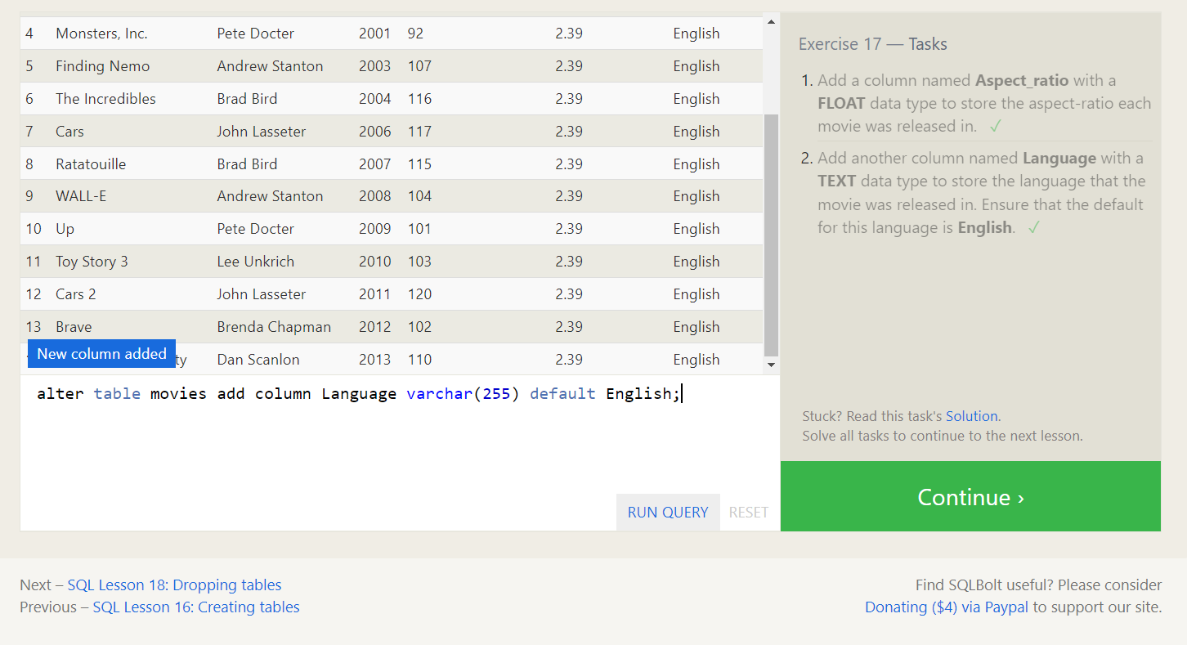

**SQL Lesson 18: Dropping tables:**

1. We've sadly reached the end of our lessons, lets clean up by removing the **Movies** table

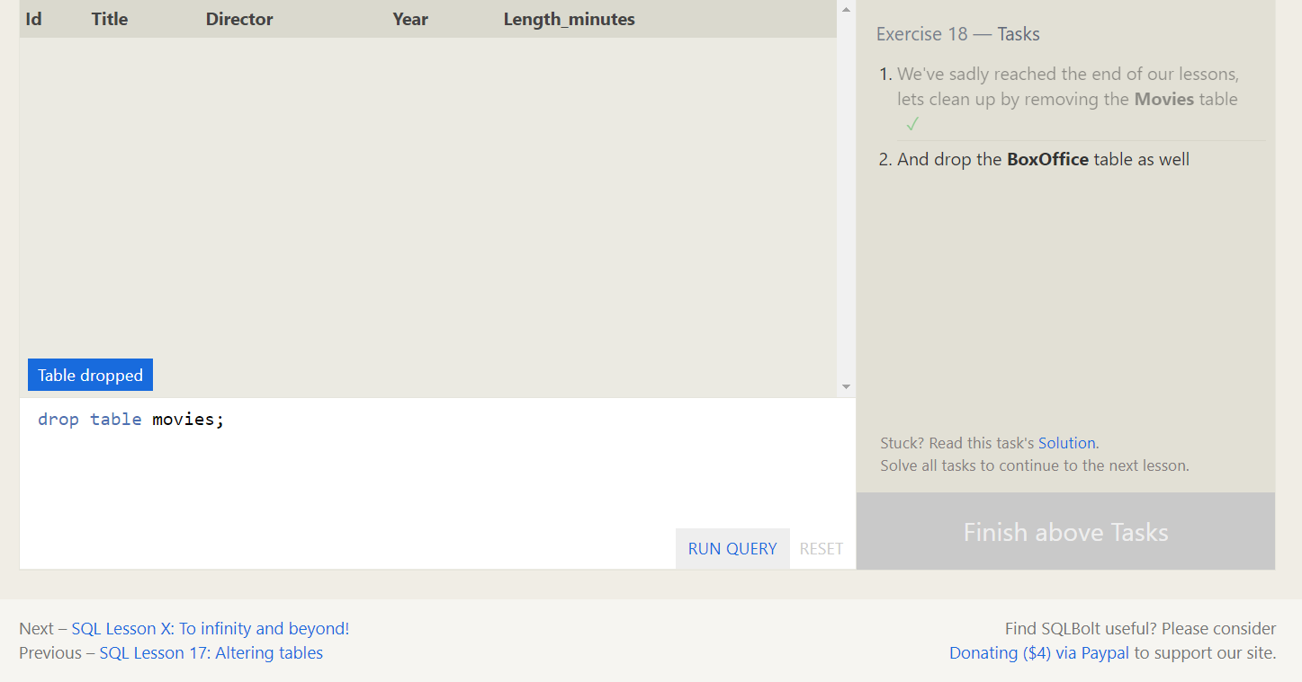

1. And drop the **BoxOffice** table as well

